**Module-1**

**Exercise 1: Try To Create User Details Form.**

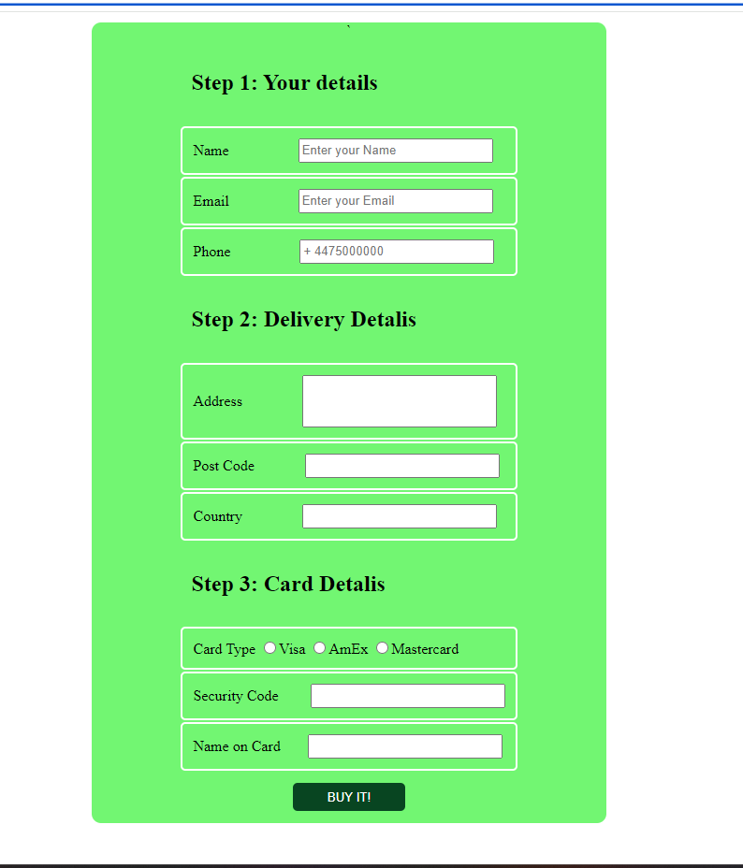

**BOOTSRAP**

**Exercise 1: Create manage Profile:**

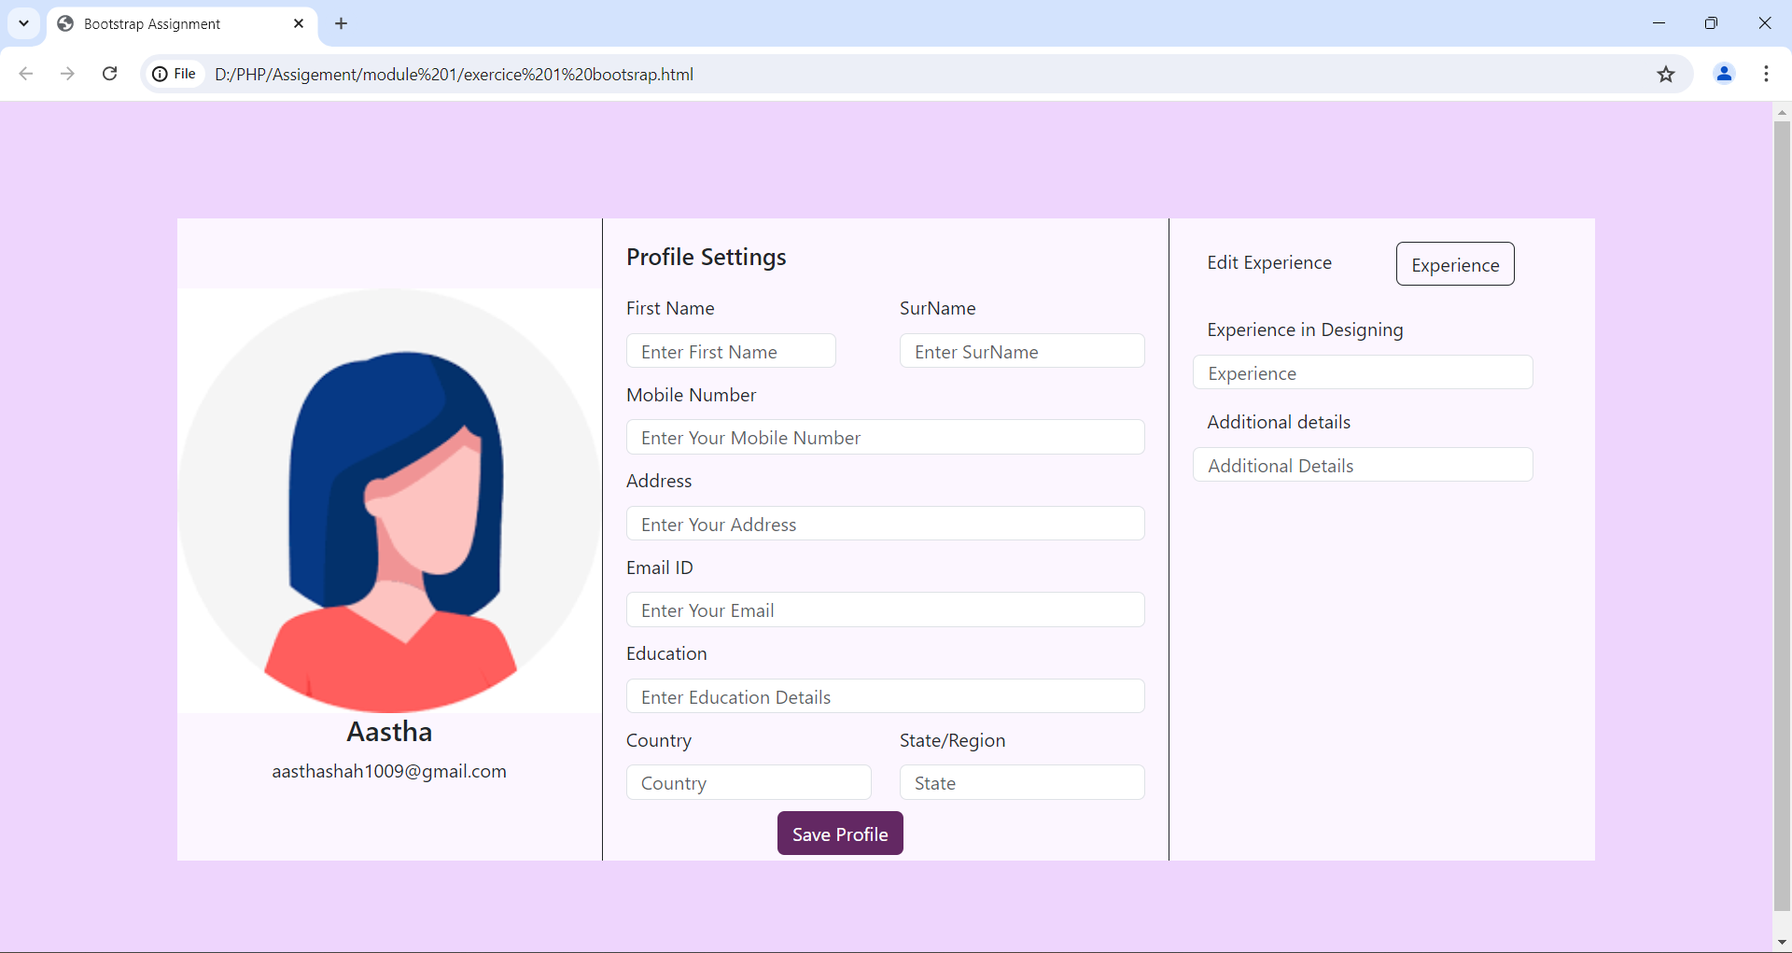

**Exercise 2 : Create Product Listing Page:**

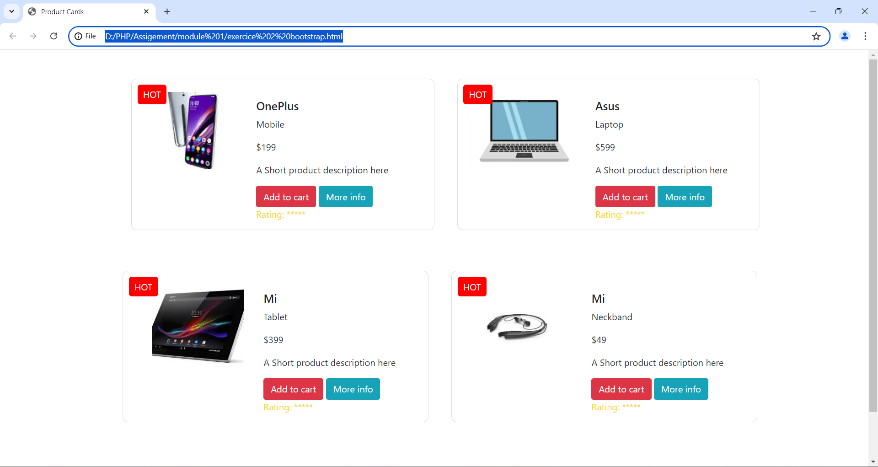

**Topic – SQL Task-1**

1. Get First_Name from employee table using alias name “Employee Name”.

Ans: SELECT First_Name AS 'Employee Name'FROM employee;

1. Get FIRST_NAME, Joining year, Joining Month and Joining Date from employee table.

Ans: SELECT FIRST_NAME,

TO_CHAR(joining_date, 'YYYY') AS JoinYear,

TO_CHAR(joining_date, 'Mon') AS JoinMonth,

TO_CHAR(joining_date, 'dd') AS JoinDate FROM employee;

1. Get all employee details from the employee table order by First Name Ascending And Salary descending?

Ans: SELECT *FROM employee ORDER BY First_Name ASC, Salary DESC;

1. Get employee details from employee table whose first name contains “%o”.

Ans: SELECT *FROM employee WHERE First_Name LIKE 'o';

1. Get employee details from employee table whose joining month is “January”.

Ans: SELECT *FROM employee WHERE joining month = 01;

1. Get department, total salary with respect to a department from employee table Order By total salary descending.

Ans: SELECT DEPARTMENT_NAME, SUM(SALARY) AS Total_Salary FROM employee GROUP BY DEPARTMENT_NAME ORDER BY Total_Salary DESC;

1. Get department wise maximum salary from employee table order by salary ascending?

Ans: SELECT DEPT_ID, MAX(SALARY) FROM department GROUP BY DEPT_ID ORDER BY MAX(SALARY) ASC;

1. Select first_name, incentive amount from employee and incentives table for those Employees who have incentives and incentive amount greater than 3000.

Ans: SELECT FIRST_NAME, INCENTIVES FROM employee A INNER JOIN incentives B ON A.EMPLOYEE_ID = B.EMPLOYEE_REF_ID WHERE INCENTIVE_AMOUNT > 3000;

1. Select 2nd Highest salary from employee table.

Ans:

1. Select first_name, incentive amount from employee and incentives table for all Employees who got incentives using left join.

Ans: SELECT FIRST_NAME, IFNULL(B.INCENTIVE_AMOUNT, 0) FROM employee LEFT JOIN incentives ON EMPLOYEE_ID = EMPLOYEE_REF_ID;

1. Create View OF Employee table in which store first name, last name and salary only.

Ans: CREATE VIEW employee_info AS SELECT first_name, last_name, salary FROM employee;

1. Create Procedure to find out department wise highest salary.

Ans: CREATE OR REPLACE PROCEDURE GetHighestSalaryPerDept AS BEGIN SELECT EmpID, MAX(Salary) AS HighestSalary FROM EmpDetails GROUP BY EmpID;

END;

1. Create after Insert trigger on Employee table which insert records in view table.

Ans:

**Task-2:**

1. All orders for more than $1000.

Ans: SELECT * FROM order WHERE onm > 1000 ;

1. Names and cities of all salespeople London with commission above 0.10.

Ans: SELECT sname , city from salesperson WHERE commission > 0.10;

1. All salespeople either in Barcelona or in London.

Ans: SELECT * WHERE city=” Barcelona” OR city=” London”;

1. All salespeople with commission between 0.10 and 0.12. (Boundary values should be excluded).

Ans: SELECT salesman_id, name, city, commission FROM salesman WHERE commission > 0.10 AND commission < 0.12;

1. All customers with NULL values in city column.

Ans: SELECT * FROM Customers WHERE city IS NULL;

1. All orders taken on Oct 3Rd and Oct 4th 1994.

Ans: SELECT * FROM orders WHERE ODE BETWEEN '1994-10-03' AND '1994-10-04';

1. All customers serviced by peel or Motika.

Ans:

1. All customers whose names begin with a letter from A to B.

Ans: SELECT sname FROM sales person WHERE sname LIKE 'A%' OR sname LIKE 'B%' ORDER BY sname;

1. All customers excluding those with rating <= 100 unless they are located in Rome.

Ans:

1. All orders except those with 0 or NULL value in amt field.

Ans: SELECT * FROM orders WHERE amt IS NOT NULL AND amt > 0;

1. Count the number of salespeople currently listing orders in the order table.

Ans: